|  |  |
| --- | --- |
|  | Student Name _______________________  **Eastern Goldfields College**  Mathematics Specialist Year 11 2019  Assignment Validation – Calculator Free |
| Reading Time: 1 minute  Working Time: 15 minutes | Total Marks: 15 marks |

Question 1 (7 marks)

(a) A body moves from $P(2, -3)$ to $Q(-3, 2)$.

(i) Determine the displacement vector $\vec{PQ}$ in component form. (1 mark)

(ii) Determine the magnitude of the vector $\vec{PQ}$. (1 mark)

(b) A force of $-6\sqrt{3}i+6j$ N acts on a body. Determine the magnitude of the force and the angle its direction makes with the positive $x$-axis. (2 marks)

(c) A body moves with a velocity of 20 ms-1 at an angle of 120° with the positive $x$-axis. Express the velocity of the body in the form $ai+bj$, where $a$ and $b$ are constants.

(3 marks)

Question 2 (8 marks)

(a) Determine the number of different three-letter passwords that can be made by arranging a selection of three letters chosen from the list P, Q, R, R, R and S. (4 marks)

(b) Determine the number of positive integers between 1 and 240 inclusive that are divisible by at least one of the integers 4, 5 or 6. (4 marks)

|  |  |
| --- | --- |
|  | Student Name _______________________  **Eastern Goldfields College**  Mathematics Specialist Year 11 2019  Assignment Validation – Calculator Assumed |
| Reading Time: 1 minute  Working Time: 16 minutes | Total Marks: 16 marks |

Question 3 (8 marks)

(a) In the diagram, , $B$, $C$ and $D$ lie on the circumference of circle with centre $O$. Given that $∠ADC=55°$, $∠BCO=63°$ and $∠DCO=23°$ determine the values of $a$, $b$ and $c$. (3 marks)

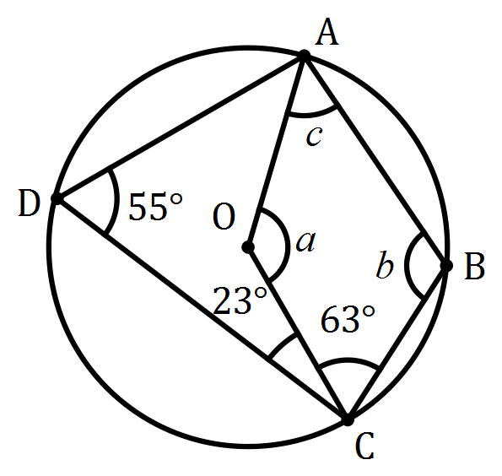

(b) In the diagram below, points $B$, $C$ and $D$ lie on the circumference of circle centre $O$ and $AB$ and $AD$ are tangents to the circle.

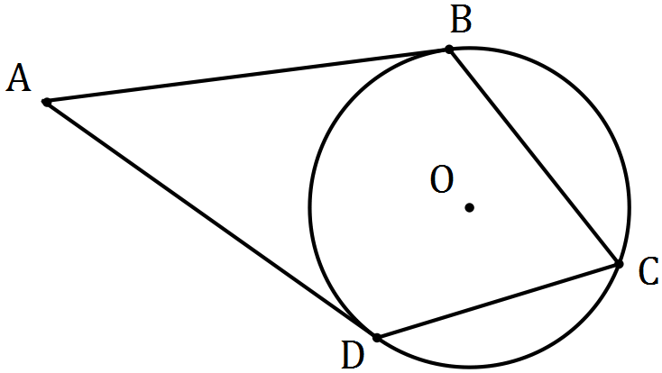

(i) Prove that $ABOD$ is a cyclic quadrilateral. (3 marks)

(ii) Determine the size of $∠BAD$ if the size of $∠BCD=82°$. (2 marks)

Question 4 (8 marks)

(a) Show that the vectors $a=\left(\begin{matrix}2 \\ -1\end{matrix}\right)$ and $b=\left(\begin{matrix}-6 \\ 3\end{matrix}\right)$ are parallel. (2 marks)

(b) Points $A$, $B$ and $C$ have position vectors $\left(\begin{matrix}2 \\ -5\end{matrix}\right)$, $\left(\begin{matrix}-3 \\ 5\end{matrix}\right)$ and $\left(\begin{matrix}0 \\ -1\end{matrix}\right)$ respectively. Use vectors to prove that $A$, $B$ and $C$ are collinear. (3 marks)

(c) Points $P$ and $Q$ have position vectors $\left(\begin{matrix}4 \\ 1\end{matrix}\right)$ and $\left(\begin{matrix}9 \\ 16\end{matrix}\right)$ respectively. Determine the position vector of the point $R$ that divides $PQ$ internally in the ratio $2:3$. (3 marks)